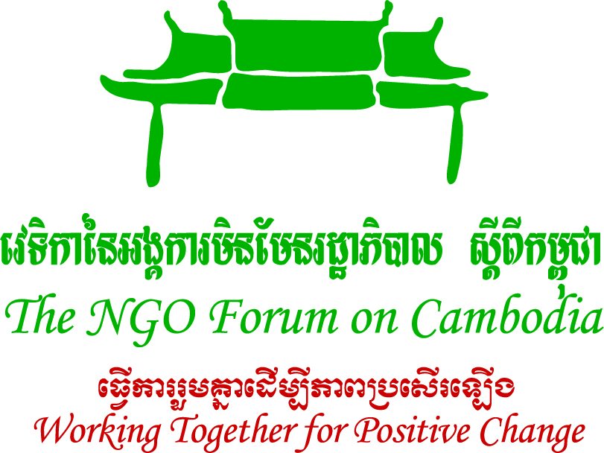
THE NGO FORUM ON CAMBODIA AND SAVE THE MEKONG COALITION

Date: 15 November, 2012 MEDIA ALERT
PRESS CONFERENCE TO OPPOSE XAYABURI DAM
On Friday 16 November at 10.30 am, NGOs led by the NGO Forum on Cambodia and the Rivers Coalition in Cambodia will hold a press conference to call for a stop to any further development of the Xayaburi Dam in Laos.
NGOs are addressing a letter to the four Prime Ministers of Cambodia, Laos, Vietnam and Thailand, calling for cessation of all activity on the Xayaburi Dam.
NGOs are also calling on ASEAN and the international community to take swift action to protect the Mekong River by agitating for an end to the Dam.
This issue is urgent and must be addressed by ASEAN leaders. The Laos Government’s announcement that it will push ahead with the Xayaburi Dam is in direct violation of the Laos and Thai Governments’obligations under the 1995 Mekong Agreement to negotiate with other member countries regarding changes to the river.
The Mekong River Commission’s countries have not formally agreed to this project and all construction should cease.
WHAT: Press conference at which NGOs will call for cessation of Xayaburi Dam work.

WHEN: Friday 16 November, 2012

10.30 am

WHERE: The NGO Forum Office, 9-11, st 476, Toul Tompoung 1 Phnom Penh

WHO: Mr. Chhith Sam Ath, Executive Director of NGO Forum on Cambodia;
Mr. Youk Senglong, Deputy Director of Buddhist Association for Environmental Development;
Mr. Long Sochet, Chief of Coalition of Cambodia Fisheries
Mr. Yen Bora, Sesan Community Representatve
Ms. Premrudee Daoroung, Co-director of Toward Ecological Recovery and Regional Alliance Reliance/Foundation for Ecological Recovery (PER), Thailand – Moderator
Ms. Shalmali Guttal, Focus on the Global South

MEDIA CONTACT:
For comment: Mr Chhith Sam Ath, NGO Forum 012 92 8585
For more information Ms Chea Phallika 012 895 830 or Mr Phourn Yu 017 575 808

